**DAILY ONLINE ACTIVITIES SUMMARY**

|  |  |  |  |  |  |  |  |
| --- | --- | --- | --- | --- | --- | --- | --- |
| **Date:** | **1/06/2020** | | | | **Name:** | **Tushit Shukla** | |
| **Sem & Sec** | **4 sem & B sec** | | | | **USN:** | **4AL18CS093** | |
| **Online Test Summary** | | | | | | | |
| **Subject** | | **DC IA Test**  **MATHS IA Test** | | | | | |
| **Max. Marks** | | **30** | | **Score** | | **27** | |
| **Certification Course Summary** | | | | | | | |
| **Course** | 1. Java programing | | | | | | |
| **Certificate Provider** | | | **Great Learning** | **Duration** | | | **1s hr(spent by me on that day to learn)** |
| **Coding Challenges** | | | | | | | |
| **Problem Statement:**  1 An element of array is leader if it is greater than or equal to all the elements to its right side. Also, the rightmost element is always a leader.  2 [Given an array arr[] of size N and an integer K. The task is to find the count of subarrays such that each subarray has exactly K distinct elements.](https://github.com/orgs/alvas-education-foundation/teams/2nd-year/discussions/90) | | | | | | | |
| **Status: Completed** | | | | | | | |
| **Uploaded the report in Github** | | | | **Yes** | | | |
| **If yes Repository name** | | | | <https://github.com/tushitshukla29/lockdown-program> | | | |
| **Uploaded the report in slack** | | | | **Yes** | | | |

**Online Test Details**

MATHS TEST Details:

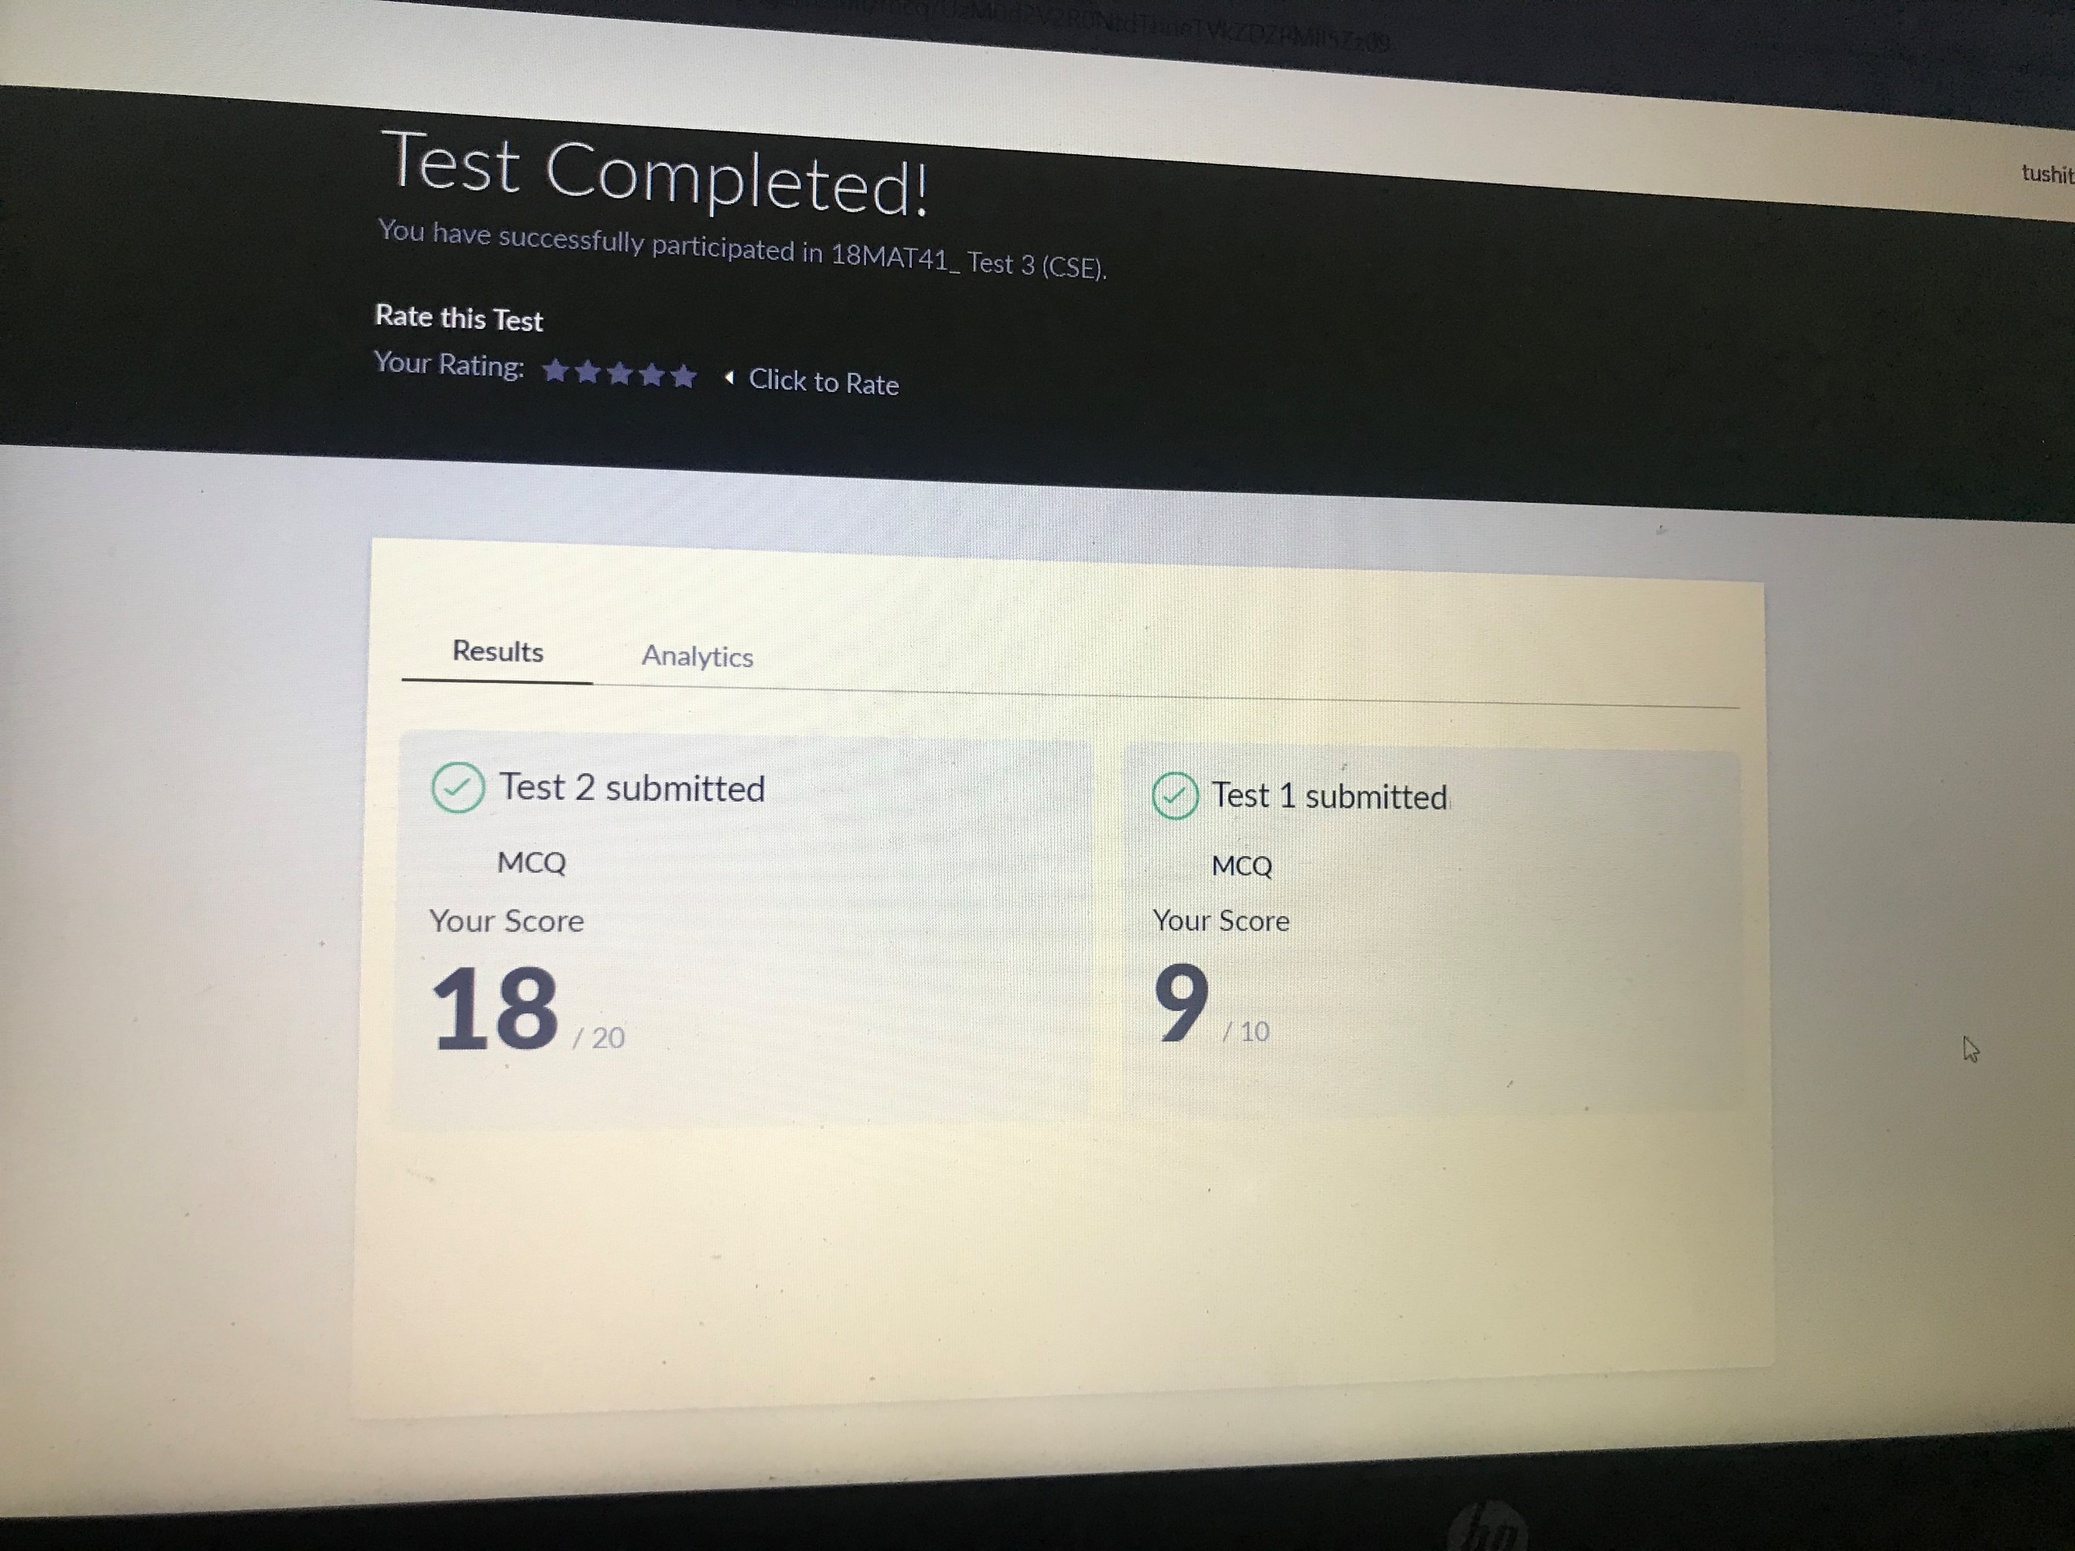

**Online Certification Details**:

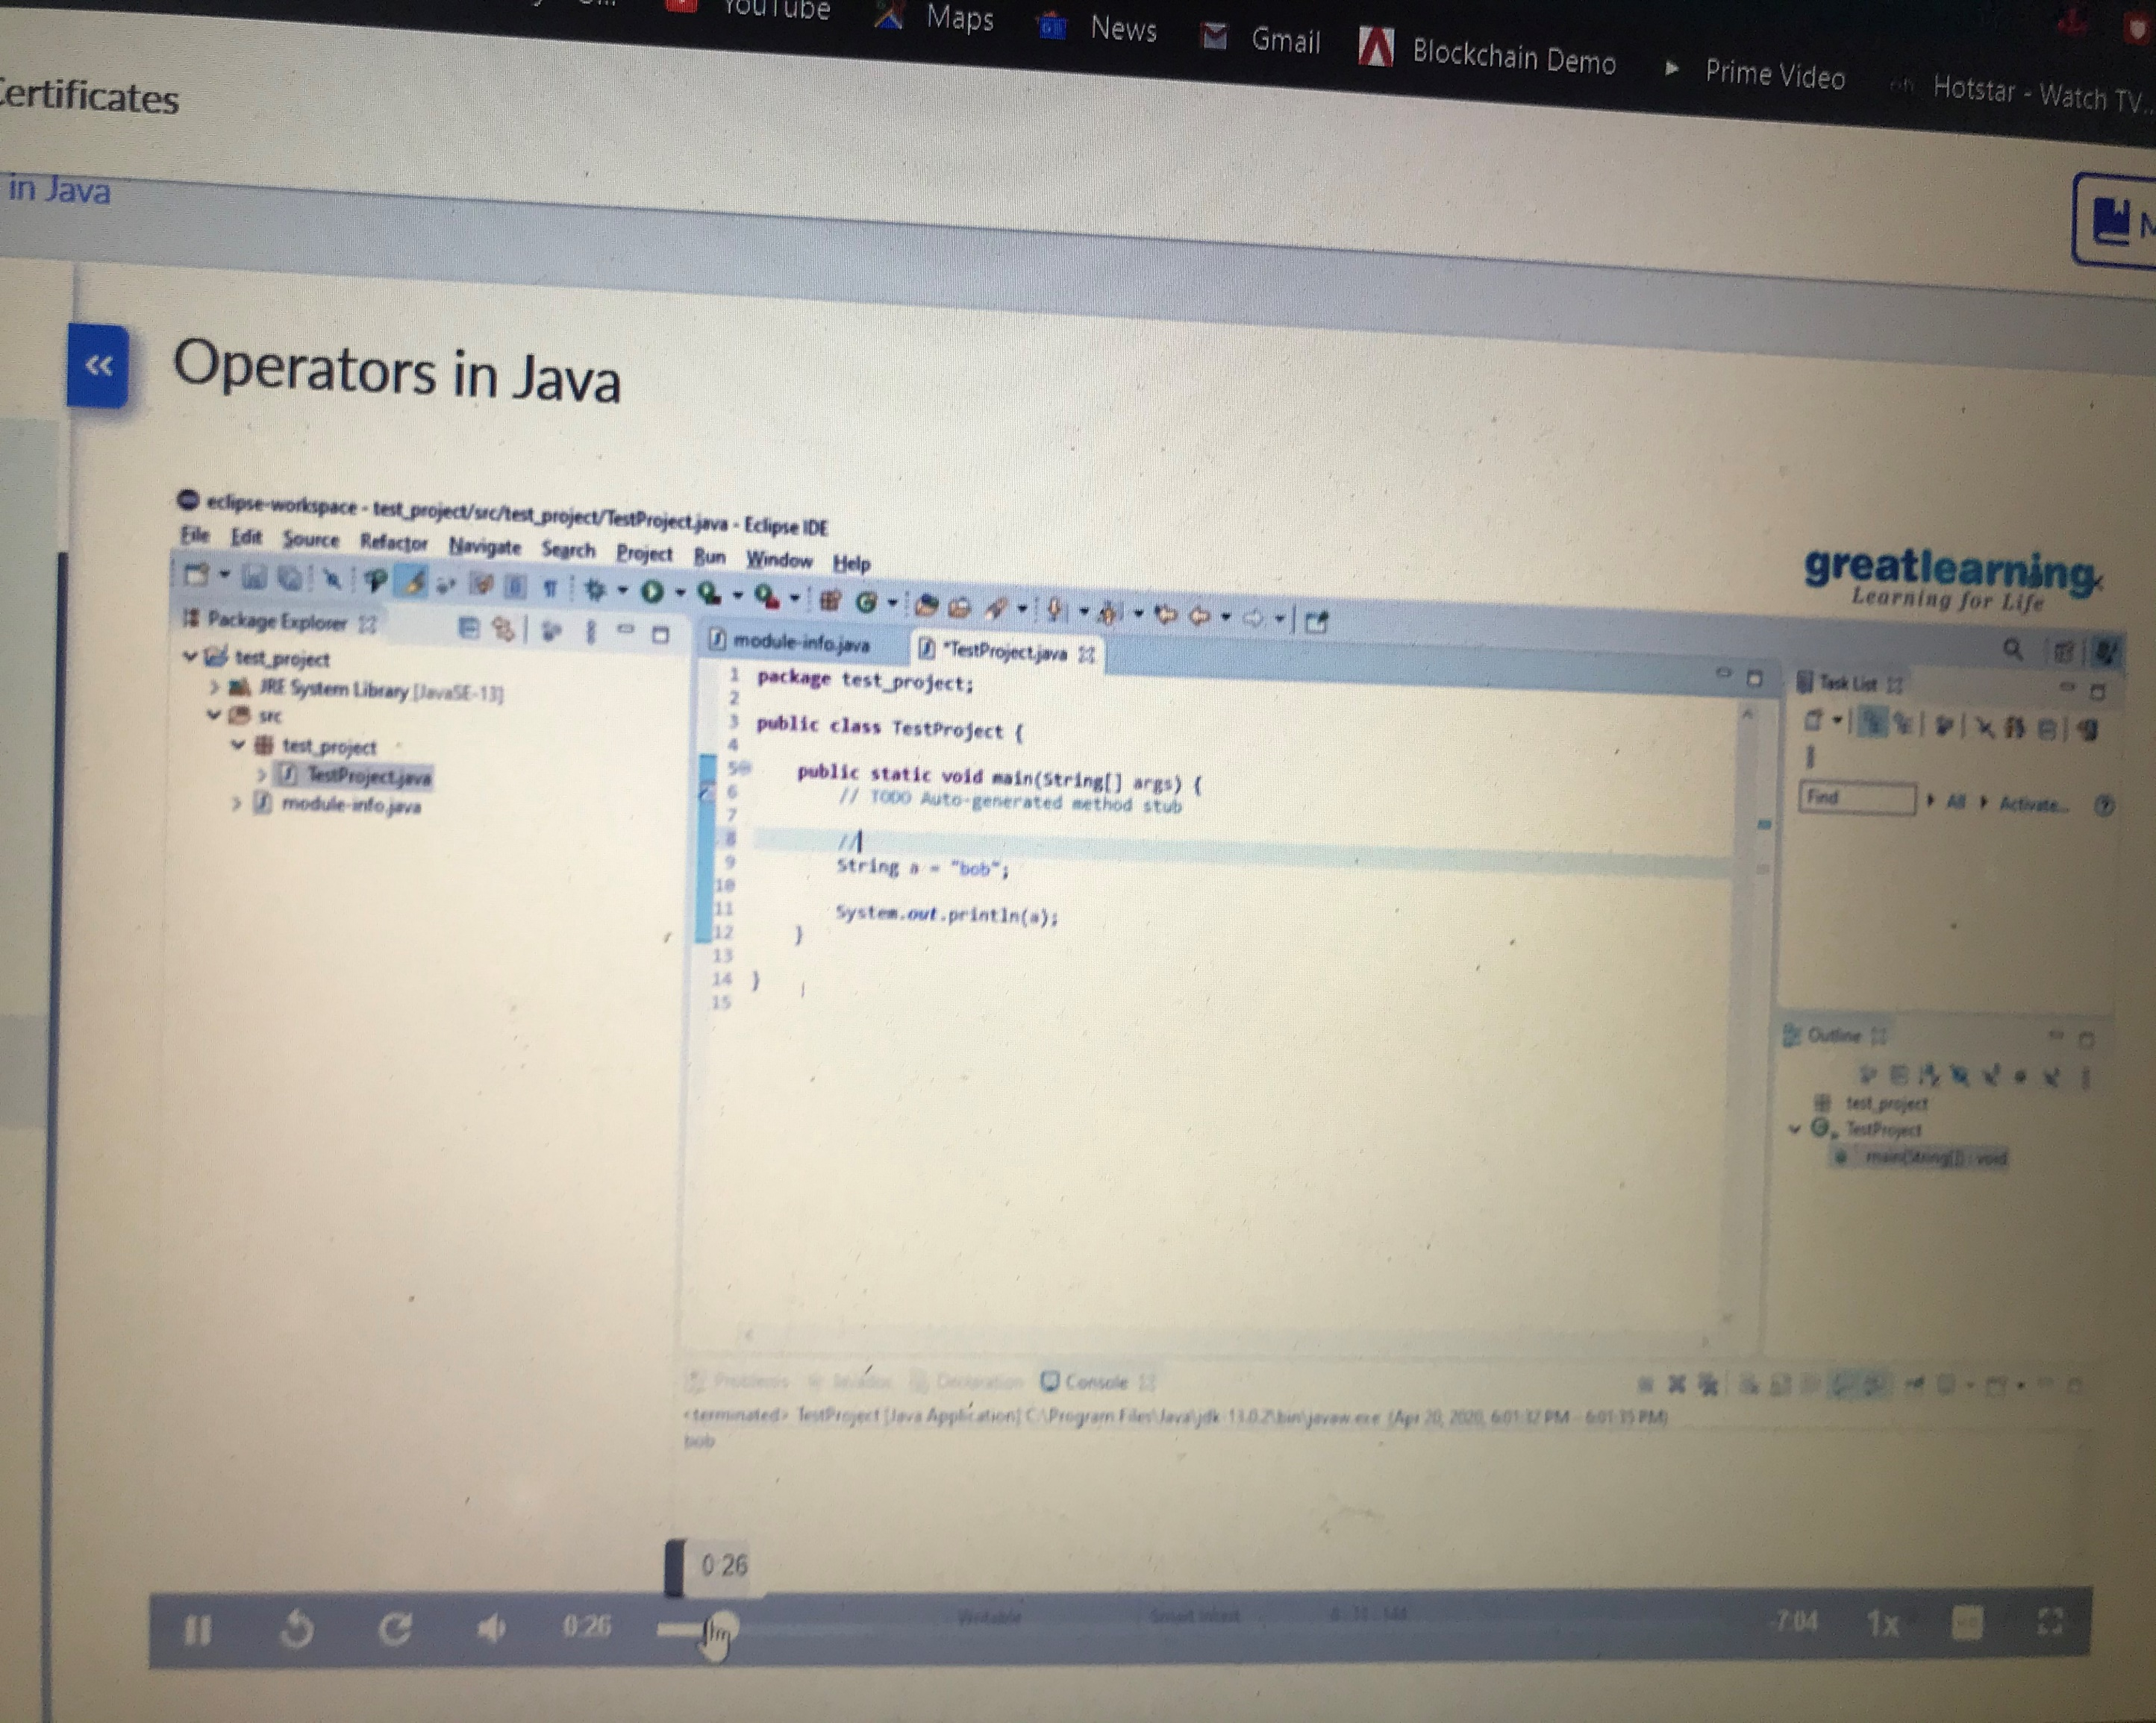

**Coding Challenge Detail :** I have written programs and uploaded it to my Github repository.

Link as follows: 1 <https://github.com/tushitshukla29/lockdown-program/blob/master/leaders%20in%20array>

2 <https://github.com/tushitshukla29/lockdown-program/blob/master/leaders%20in%20array>